**My Wardrobe(E-commerce website)**

Online Shopping Site for Fashion & Lifestyle. It brings you a variety of footwear, Clothing, Accessories and lifestyle products and much more.

**This image just a sample of the website, it’s a reference of the website**

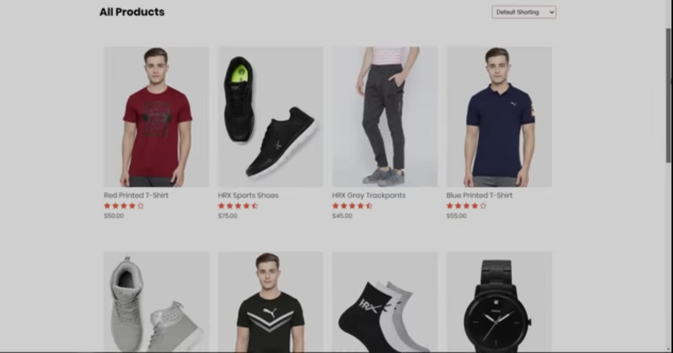

Navigation bar (on top)

* Logo Company Name
* Product
* About us
* Contact us
* Account (login/create account)
* Cart

Filters

* Sort by price
* User rating
* Price ranges
* Popular brands
* discount

Item’s list

* Each item in separate division.
* Image of item and name
* Price and ratings
* Featured products and latest products section
* Clicking on any product you will be taken to the product details page

Product Details Page

**A reference of the product details page (Sample image)**

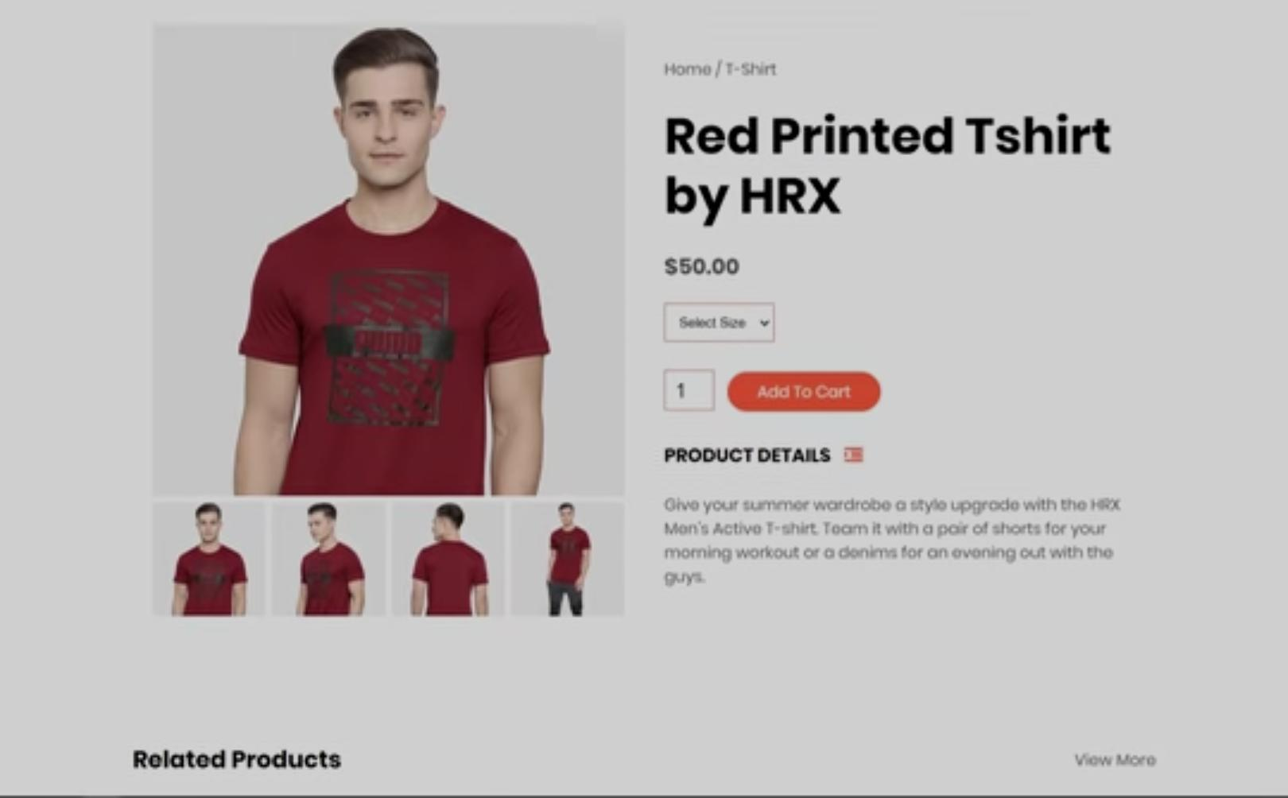

Advertisements and offers

* Exclusive Product Section and offers section
* New release and offers

Registration and Login

* For registration username, email address and password section
* For login username and password section

Payment

* Address Section
* Payment Gateway